Employee Recognition Award
Nomination Form

For this award, our judging panel are looking for individuals who stand out by:
- Inspiring others that they work with
- Creating and encouraging a positive working environment
- Demonstrating innovation with a commitment to bringing about improvement
- Sharing knowledge and offering support to all those that they work with, including partner agencies

Date
Employee and team/service area | The person you wish to nominate
Reason for nomination | Tell us what makes this person stand out…….what have they done that’s special? (Max 150 words)
What corporate values and behaviours have they demonstrated?  *Our corporate values and behaviours are located at the bottom of the form | Which corporate values and behaviours has this individual demonstrated and how? (Max 150 words)
What added value does this bring? | How does this add value or show best practice? (Max 150 words)
What impact has it had on the residents of the city and/ or on colleagues | Tell us about the impact this individual has had on the residents of the city and/or colleagues they work with. (Max 150 words)
Name of Nominee – the person making the nomination (you)

Line Manager endorsement

Head of Service endorsement

*Please note this MUST be endorsed by a line manager and Head of Service in order to be considered*

Please email to:
ASC staff – joe.morley@hullcc.gov.uk
City Safe staff – Julie.franklin@hullcc.gov.uk
Public Health and Public Protection staff – Cherie.wiles@hullcc.gov.uk

Values
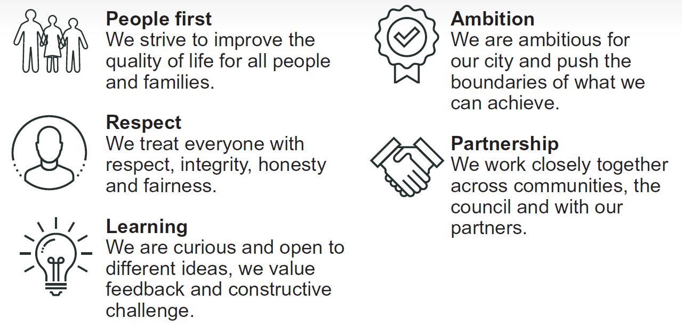
Behaviours
