Collaborative Working Recognition Award
Nomination Form

*This award is to recognise a team or a project or where colleagues have worked together on a task or case

For this award, our judging panel are looking for a team/collaboration who stand out by:
- Showing commitment to developing effective and positive team working
- Working together to respond to the changing needs of the residents of the city
- Demonstrating creativity and innovation to bring about improvement
- Demonstrating a positive impact on the residents of the city and/or colleagues they work with

Date
Team/project/ task name and service area | The team/project/group you wish to nominate
Who works in the team/project/group | We need to know the number of staff in the team/project/group and their names please
Reason for nomination | Tell us what makes this team/project/group stand out……. what have they done that’s special? (Max 150 words)
What corporate values and behaviours have they demonstrated?  *Our corporate values and behaviours are located at the bottom of the form | Which corporate values and behaviours have this team/project/group demonstrated and how? 9Max 150 words)
What added value does this bring? | How does this add value or show best practice? (Max 150 words)
What impact has it had on the residents of the city and/or colleagues | Tell us about the impact this team/project/group has had on the residents of the city and/or colleagues they work with. (Max 150 words)
Name of Nominee – the person making the nomination (you)

Line Manager endorsement

Head of Service endorsement

*Please note this MUST be endorsed by a line manager and Head of Service in order to be considered*

Please email to:
ASC staff – joe.morley@hullcc.gov.uk
City Safe staff – Julie.franklin@hullcc.gov.uk
Public Health and Public Protection staff – Cherie.wiles@hullcc.gov.uk

Values
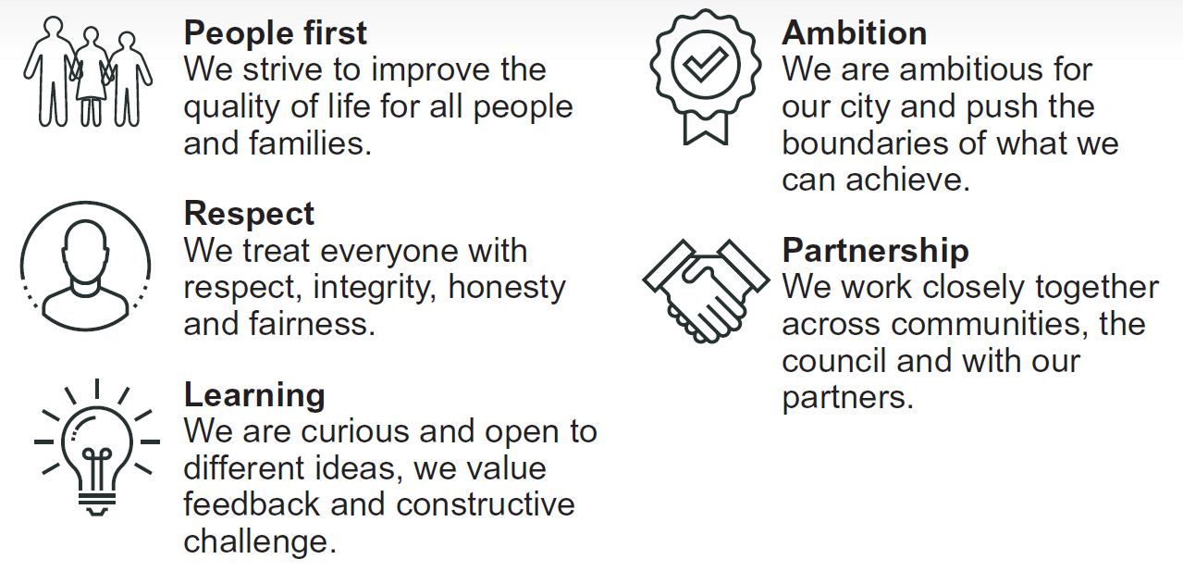
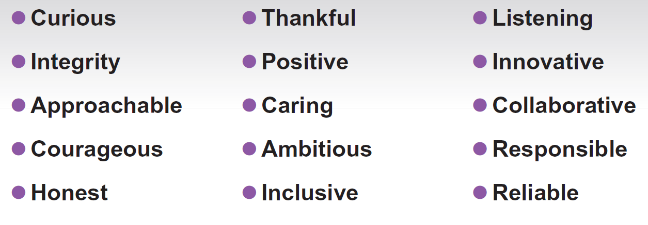
Behaviours

